Scope & Scheduling
Work Breakdown Structure (WBS)
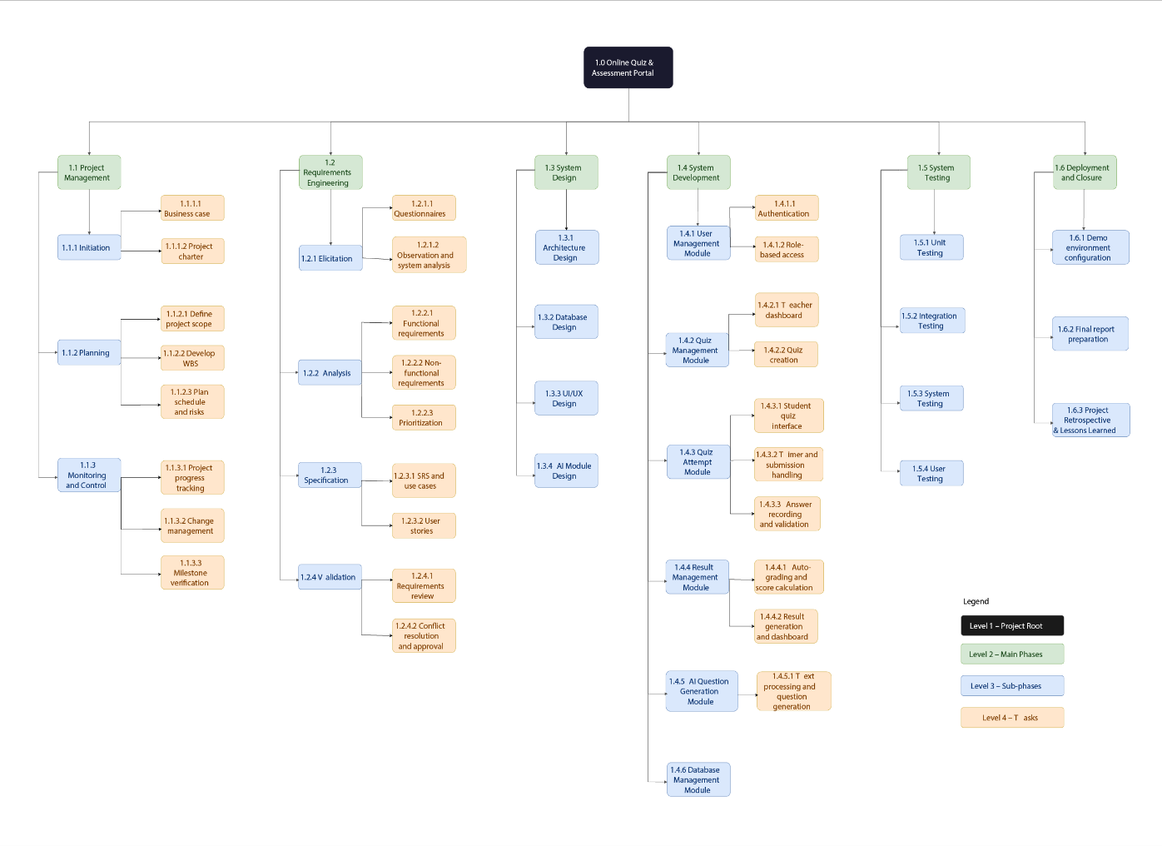
Gantt Chart
